Daniel and the Lions
WORD SEARCH

Look for 6 “LION”s
and 1 “DANIEL”

N D W W L I O N N E L G A B
O G O A O X A O R T I G R C
N B E N C Y M W I V O P Q S
L I O N I X V E E P N C K N
V B C F S I L I N Z O C A F
W I E S X C L Q H I I J L L
H Q U V M P N Z C N R X O Z
E A I H O D B K O M L I O N
V Y X Z A A A R K K I Q N Q
N Y R S O N M A W W O P U D
P I L Z X I A E A U N X J K
W U I O D E N R M C G E C B
Z H O R Z L Y L T Z J U Y P
E W N D I C S I M X D J J G

Daniel chapter 6 verses 20-22

The king spake and said to Daniel,

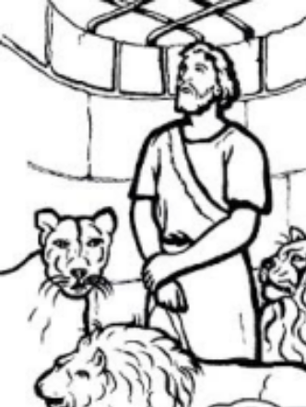
Then said Daniel unto the king,
O king, live for ever. My God hath sent his angel, and hath shut the lions' mouths, that they have not hurt me: forasmuch as before him innocency was found in me;
O Daniel, servant of the living God, is thy God, whom thou servest continually, able to deliver thee from the lions?

Answer Key
Daniel and the Lions
WORD SEARCH

Look for 6 “LION”s
and 1 “DANIEL”

