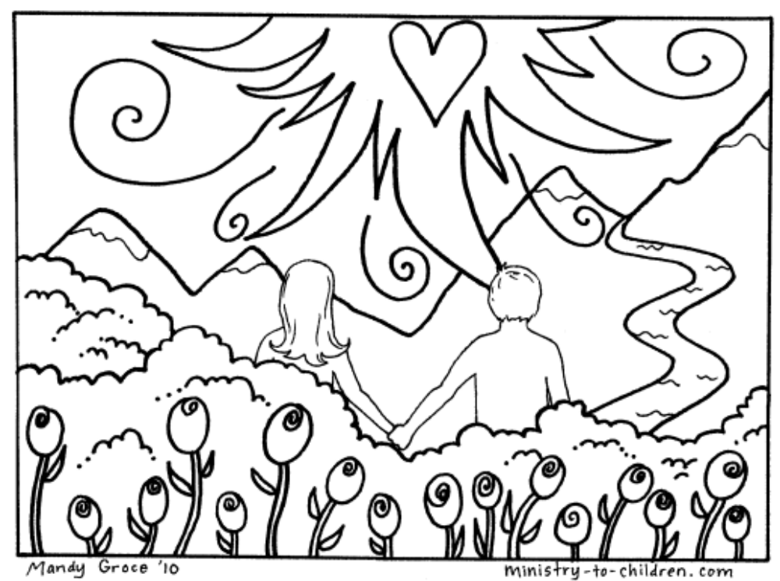
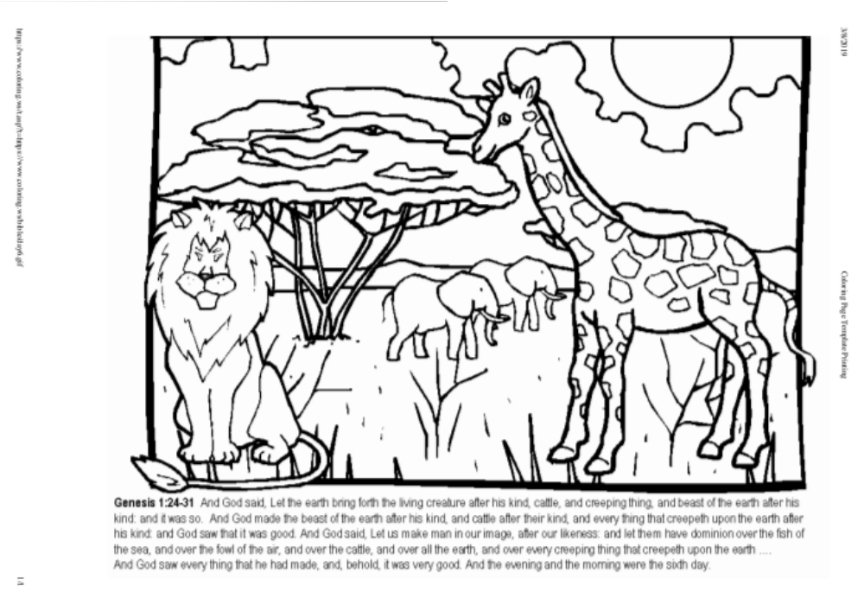
DAY 6
“Male and female created he them...”
The first job God gave Adam was to name all the animals.
Can you think of some animals that Adam named?
Write them below!
“Let the earth bring forth the living creature after his kind...”

