




O D I D N T C C P T C A N’ A R I I I C
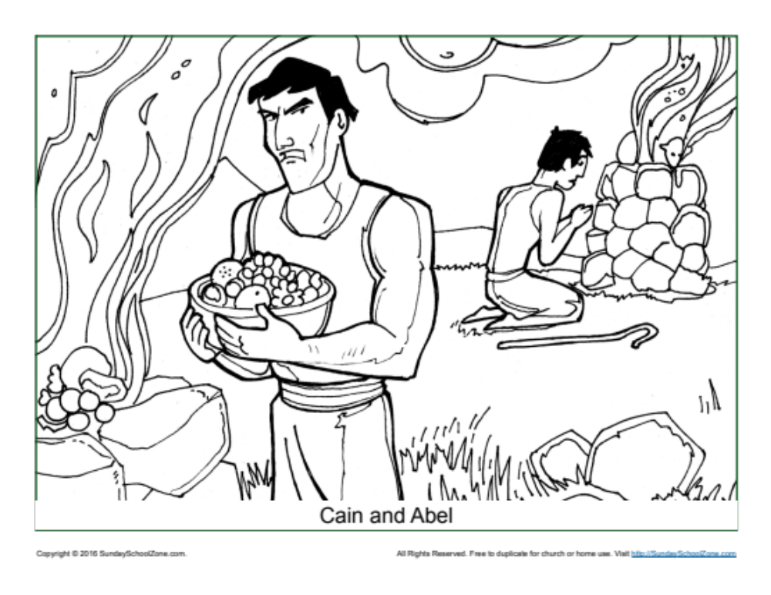
Words:

YIELD
DEAD
LAMB
SLEW
SIN
TALK
Words:

FRUIT
ABEL
CAIN
BROTHER
GROUND
FIELD
ANSWER KEY
12

7
5

4

3

11

10

1

8
9

6

2

O D I D N T C C P T C A N’ A R I I I C
Words:

YIELD
DEAD
LAMB
SLEW
SIN
TALK

Words:

FRUIT
ABEL
CAIN
BROTHER
GROUND
FIELD
